- Create python script file with contents from “pythonscript.py” text file
  - Vim pythonscript.py
  - Copy contents from text file “pythonscript.py”
  - Save pythonscript.py
  - Chmod +x pythonscript.py
- Run bash command to run the python script:
  - Python3 pythonscript.py
  - Enter values for the prompts
Please see screenshot below for Steps 1 and 2
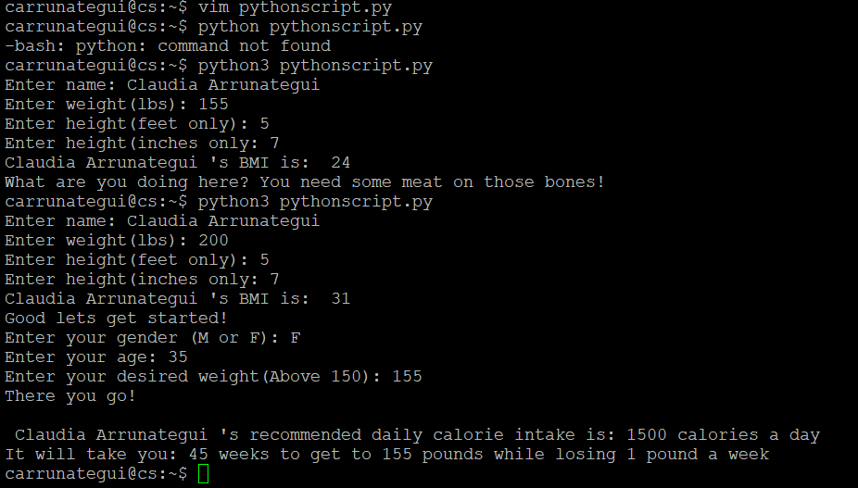
- Create awkProject.awk script with contents from awkProject.awk text file
  - Vim awkProject.awk
  - Chmod +x awkProject.awk
- Run awk script as follows:
  - ./awkProject.awk userResults.txt > awkOutput.txt
  - Check that awkOutput.txt was created and variables were saved
Please, see screnshots below for Steps 3 and 4
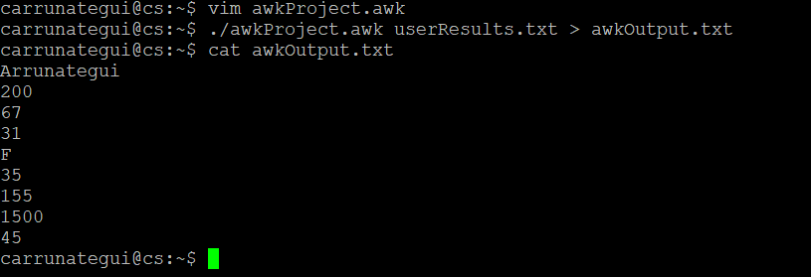
- Create testingPERL.pl file with contents from testingPERL.pl text file
  - Vim testingPERL.pl
  - Chmod +x testingPERL.pl
- Run PERL script as follows:
  - ./testingPERL.pl awkOutput.txt outputfile.html
  - Check that outputfile.html was created and displays contents

Please, see screnshots below for Steps 3 and 4
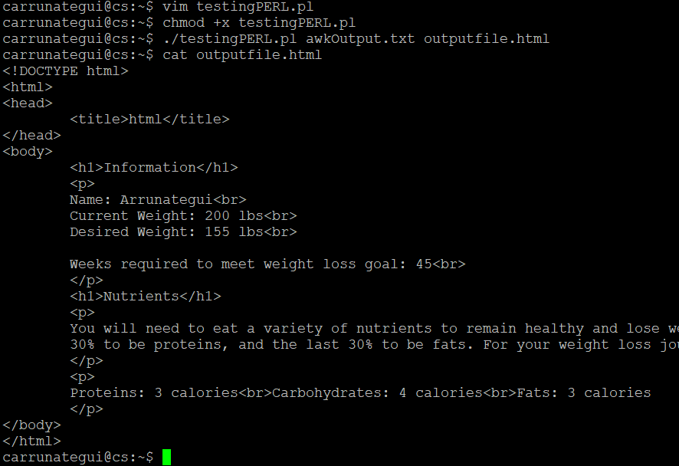
OPTIONAL: copy outputfile.html into htmlviewer to view HTML code in web page.

The following is a bash script we created to manage directories and files as well as execute Linux commands.
The script goes through the following steps:
- It clears the bash shell screen
- It creates a new text file called “new_file.txt” and it adds two lines of text to the file
- It checks it the folder “new_folder” exists; if it does, then it will remove it
- It updates the permissions of the file “new_file.txt”
- It adds a new folder to the current directory called “new_folder”
- It moves the file “new_file.txt” to the new folder created above
- It moves the “outputfile.html” file that was created when running the scripts for our weight loss calculator to the “new_folder” folder created
- It lists the contents of the current working directory
- It spells out the current working directory
- It displays who is currently logged in
Create bash script by following these steps:
- Vim bash_script.sh
- Copy contents from text file “bash_script.txt” file
- Chmod +x bash_script.sh
- Run the bash script: ./bash_script.sh

Please see below screenshot of bash script:
